Good day Ma’am Karren

We would like to inform you that the following proponents of capstone 2 with the study entitle Ordering and Delivery Tracker App for Quadro King Water Station Retail Storeare availing incomplete or in-progress.

Respectfully yours,

__________ _______________

Lauron Dael Luis Gabriel Belbis

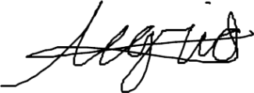

____________________

Floren Joseph A. Alegrid